Chapter 5

SYSTEM DESIGN

5.1 SYSTEM ARCHITECTURE

The HygionX system is designed using a modular, scalable, and secure client-server architecture that ensures efficient communication between different components while maintaining high performance and data integrity. The architecture is divided into multiple layers, each responsible for specific functionalities such as user interaction, data processing, intelligence computation, and storage. This layered design improves maintainability, scalability, and security of the system.
The overall architecture follows a three-tier model consisting of the Presentation Layer, Application Layer, and Data Layer. The Presentation Layer acts as the user interface, allowing users to interact with the system through a web-based chat interface. It is developed using HTML, CSS, and JavaScript, providing a user-friendly and responsive design. Users can enter symptoms in natural language and receive responses in a conversational format. The interface also displays explanations, recommendations, and confidence levels, ensuring clarity and ease of use.
The system integrates a secure authentication mechanism using Firebase Authentication, which ensures that only authorized users can access the platform. This layer handles user registration, login, and session management while protecting sensitive medical data. It also supports role-based access control, allowing differentiation between normal users and administrators. By implementing secure authentication, the system maintains data privacy and prevents unauthorized access.
The Application Layer serves as the core operational component of the system and is implemented using the Flask framework. It handles API requests, manages sessions, and coordinates communication between different modules. When a user submits a query, the backend processes the request and forwards it to the Healthcare Intelligence Engine. After processing, the generated response is sent back to the user interface. This layer ensures smooth data flow and efficient system operation through RESTful APIs.
At the heart of the system lies the Healthcare Intelligence Engine, which is responsible for analyzing user input and generating meaningful medical insights. This module uses Natural Language Processing techniques powered by HuggingFace Transformers such as MiniLM to understand user queries. It also employs Named Entity Recognition using SciSpacy to extract relevant medical entities such as symptoms and conditions. The system then performs triage and risk classification, categorizing cases into low, moderate, or high risk. Based on predefined rules and trained models, it generates recommendations and provides explanations along with confidence scores, ensuring transparency and trust.
The Knowledge Retrieval Module enhances the system by providing additional medical information to users. It fetches relevant data from external APIs or medical datasets and presents it in a simplified format. This helps users gain a better understanding of their conditions and supports informed decision-making. By combining prediction with knowledge support, the system becomes more informative and user-centric.
The Conversation and Session Management Module plays a crucial role in maintaining context throughout user interactions. It tracks chat history, maintains session continuity, and ensures that follow-up questions are relevant. By linking multiple messages and storing previously detected symptoms, this module improves the accuracy and consistency of responses, enabling a personalized user experience.
The Data Layer is responsible for storing and managing all system data using a structured MySQL database. It stores user profiles, medical history, chat logs, detected symptoms, and triage results. This structured storage enables efficient data retrieval and ensures consistency and reliability. By maintaining historical data, the system can provide personalized recommendations and track user health over time.
In addition to internal components, the system integrates with external services such as appointment scheduling APIs, medication reminder systems, and notification services. These integrations extend the functionality of the system and make it more practical for real-world healthcare applications. They also support features like follow-up notifications and telemedicine services.
The data flow in the system follows a structured process. The user inputs symptoms through the chat interface, and the request is sent to the backend. After authentication verification, the input is processed by the NLP module, where symptoms are extracted and analyzed. The Healthcare Intelligence Engine then evaluates the data, generates predictions, and assigns a risk level. The results are stored in the database and sent back to the user as a structured response. This ensures real-time processing and accurate output.
The architecture is designed with scalability and performance in mind. Its modular structure allows independent components to be updated or expanded without affecting the entire system. The use of lightweight frameworks, efficient machine learning models, and optimized database queries ensures fast response times even with increasing user load. The system is also cloud-ready, making it suitable for future deployment and scaling.
To ensure reliability, the system incorporates fault tolerance mechanisms such as error handling, backup storage, and logging. These features allow the system to handle failures gracefully without disrupting user experience. Additionally, strong security measures, including encrypted data storage, secure API communication, and controlled access, protect sensitive healthcare data and maintain user trust.
In conclusion, the HygionX system architecture is a robust and intelligent framework that combines modern web technologies with advanced artificial intelligence techniques. Its modular design, secure infrastructure, and explainable AI capabilities enable it to deliver personalized and reliable healthcare support. The architecture is flexible and future-ready, allowing integration of advanced features such as voice interaction, wearable device connectivity, and real-time telemedicine services.

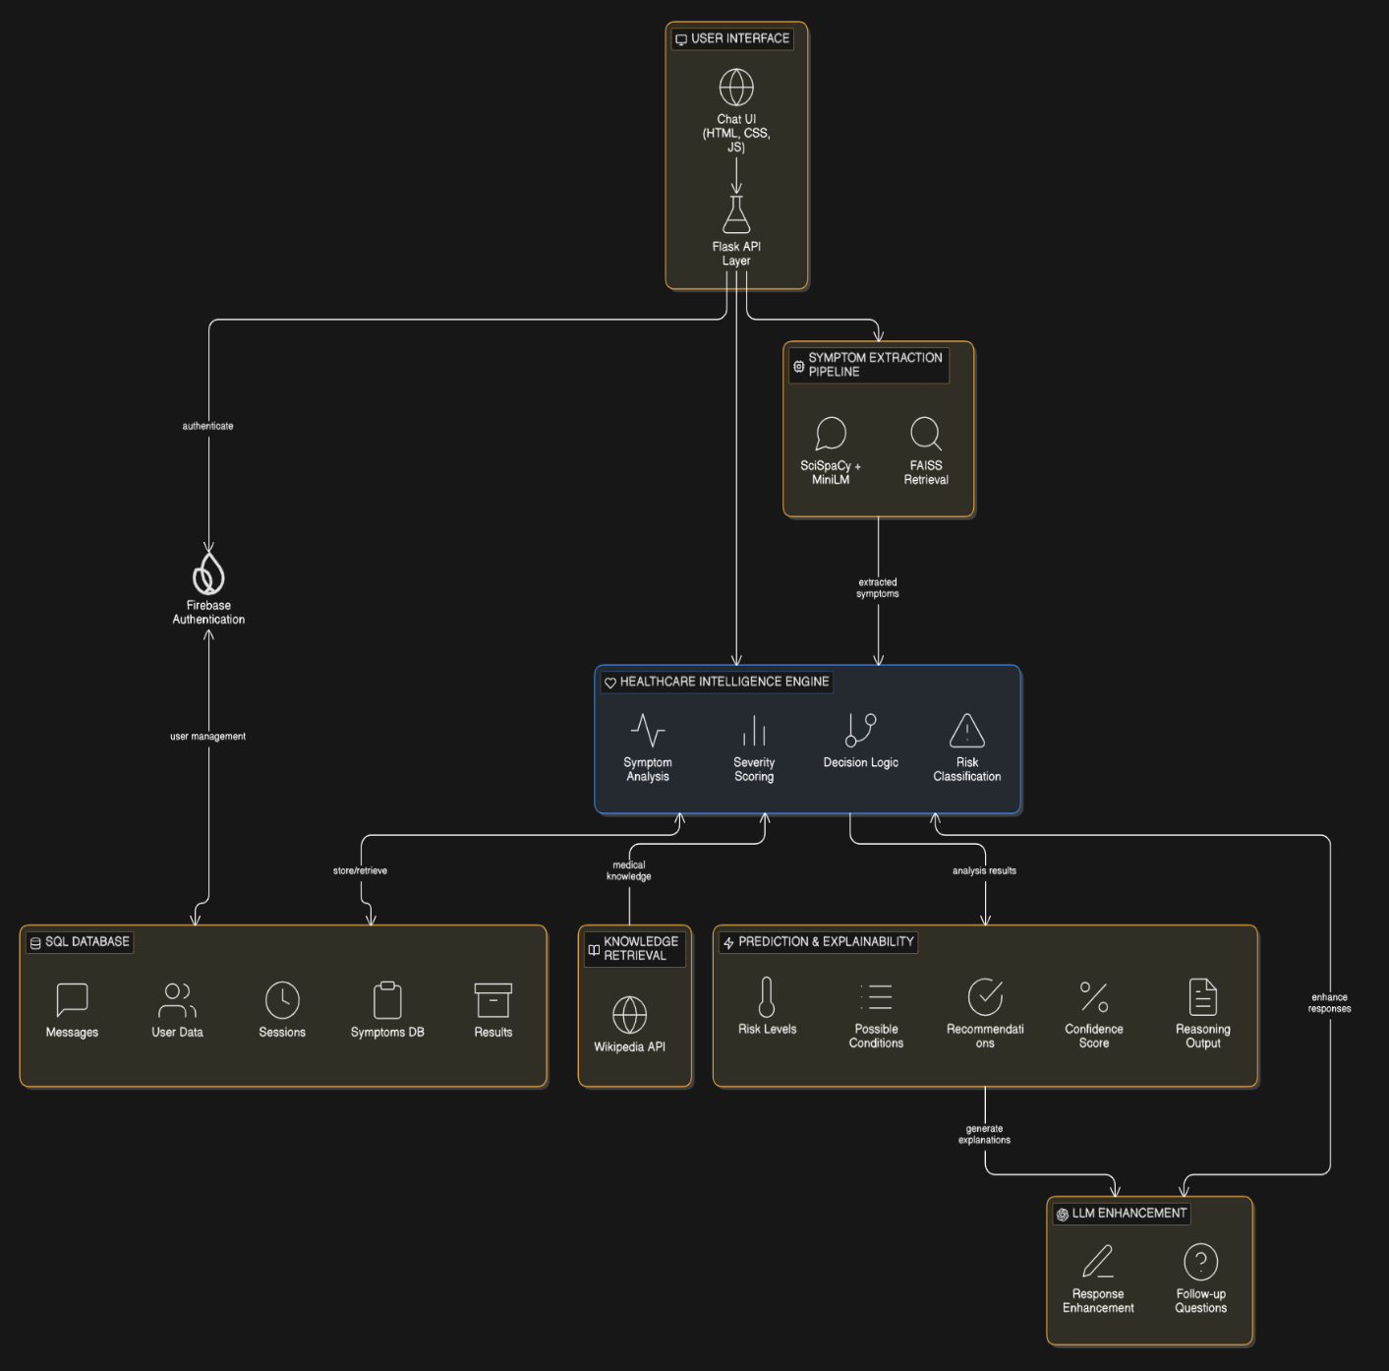
Fig 5.1.1 : System Architecture
The HygionX architecture ensures seamless integration of user interaction, AI-driven analysis, and secure data management. It enhances healthcare accessibility by providing personalized, explainable, and real-time medical guidance. The system’s scalable and modular design makes it adaptable for future advancements in digital healthcare.
5.2 UML DIAGRAMS

What is UML?
Unified Modeling Language (UML) is a standardized visual modeling language used to represent the structure, behavior, and interactions of a system. It helps in designing, analyzing, and documenting software systems through various types of diagrams. UML provides a clear blueprint of how system components interact, making it easier for developers, designers, and stakeholders to understand complex workflows.
In the context of the HygionX system, UML is used to represent how different modules such as the User Interface, Flask API, Firebase Authentication, Healthcare Intelligence Engine, Knowledge Retrieval, and Database interact with each other. It visually explains the flow of data from user input to AI processing and response generation, including symptom extraction, risk classification, and explainability outputs. By converting the system architecture into UML diagrams, the entire workflow becomes easier to understand and implement.

Contents of UML:
UML consists of different types of diagrams that represent various aspects of a system. These include:
- Use Case Diagram:
Represents the interaction between users (actors) and the system. In HygionX, it shows how users input symptoms, receive responses, and manage profiles.
- Class Diagram:
Describes the structure of the system by showing classes such as User, Session, Symptoms, and Results along with their relationships.
- Sequence Diagram:
Illustrates the step-by-step flow of messages between components, such as how a user query moves from the interface to the backend and AI engine.
- Activity Diagram:
Represents the workflow of processes like symptom analysis, risk classification, and response generation.
- Component Diagram:
Shows how different system modules (frontend, backend, database, AI engine) are organized and interact.
- Deployment Diagram:
Describes how the system is deployed across hardware and software environments, including servers, databases, and cloud services.

These diagrams collectively help in understanding both the static and dynamic aspects of the HygionX system.

Advantages of UML
UML provides several benefits in system design and development:
- Improves Visualization: Helps in clearly representing complex system architecture in an easy-to-understand graphical format.
- Better Communication: Acts as a common language between developers, designers, and stakeholders.
- Simplifies Complexity: Breaks down complex processes like NLP processing and decision-making into understandable diagrams.
- Enhances System Design: Helps in planning and organizing system components efficiently.
- Supports Documentation: Provides proper documentation for future reference and maintenance.
- Facilitates Debugging and Development: Makes it easier to identify errors and improve system workflow.
- Scalability and Flexibility: Helps in modifying and extending the system architecture as new features are added.

In this project five basic UML diagrams have been explained:
- Class Diagram
- Sequence Diagram
- Activity Diagram
- Component Diagram

Deployment Diagram

5.2.1 Class Diagram
A Class Diagram is one of the most important UML diagrams used to represent the static structure of a system. It provides a detailed view of how a system is organized by illustrating its classes, attributes, methods, and the relationships between them. Unlike dynamic diagrams that focus on system behavior over time, class diagrams act as a blueprint of the system, helping developers understand the design before implementation.
A class diagram simplifies complex systems by visually organizing components and showing how they interact at a conceptual level. It plays a crucial role in software development, database design, and system planning. In the context of the HygionX system, the class diagram represents core entities such as User, Session, Message, TriageResult, and the Healthcare Intelligence Engine (HygionXMediAITriage), which together manage user interaction, data storage, and AI-based healthcare analysis.

1. Classes
Classes are the fundamental building blocks of a class diagram, representing real-world entities or system components.
In HygionX:
- User represents patient information
- Session represents each interaction between user and system
- Message represents chat communication
- TriageResult stores AI-generated outputs
- HygionXMediAITriage represents the AI processing engine
These classes define the overall structure of the healthcare chatbot system.

2. Attributes
Attributes represent the data stored within each class.
Examples:
- User → id, email, name, known_conditions
- Session → id, user_id, title
- Message → id, session_id, role, content
- TriageResult → severity_score, risk_level, recommended_action
These attributes help store user profiles, conversation history, and medical analysis results, enabling personalized healthcare support.

3. Methods (Operations)
Methods define the behavior or functionality of a class.
In HygionX:
- extract_symptoms() → identifies symptoms using NLP
- calculate_severity_score() → evaluates severity
- generate_final_assessment() → produces final output
- process_message() → handles user queries
These methods are mainly part of the Healthcare Intelligence Engine and represent the system’s core AI processing capabilities.

4. Relationships
Relationships define how classes are connected and interact with each other.
- Association: A User can have multiple Sessions, and each Session contains multiple Messages.
- Multiplicity: One User → Many Sessions (1 to *)
One Session → One TriageResult (1 to 1)
- Dependency: The AI Engine (HygionXMediAITriage) depends on session data to generate results.
These relationships reflect real-world interactions and ensure logical system design.

5. Encapsulation
Encapsulation combines data and methods within a single class.
Example:
HygionXMediAITriage includes both:
- Data → session_symptoms, follow_up_count
- Methods → symptom extraction and analysis
This improves modularity and protects data integrity.

6. Abstraction
Abstraction hides complex internal logic and shows only essential details.
In HygionX:
- Users see only outputs like risk level and recommendations
- Internal NLP and ML processing remains hidden
This simplifies user interaction while maintaining powerful backend functionality.

7. Modularity and Reusability
The system is divided into independent classes, making it easier to:
- Maintain and update
- Extend with new features
- Reuse components in future development
This ensures scalability and flexibility of the system.
8. Real-world Mapping
The class diagram closely represents real-world healthcare processes:
- User → Patient
- Session → Consultation
- Message → Conversation
- TriageResult → Diagnosis/Advice
- AI Engine → Medical decision system
This makes the system intuitive and logically structured.
The class diagram of HygionX provides a comprehensive representation of the system’s structure by clearly defining all core components involved in the healthcare chatbot. It identifies key classes such as User, Session, Message, TriageResult, and the Healthcare Intelligence Engine, along with their roles in the system. Each class includes attributes that store important data, such as user details, chat history, and medical analysis results. It also defines methods that represent system functionalities like symptom extraction, severity calculation, and response generation.
The relationships between these classes, such as associations and multiplicity, help in understanding how different components interact with each other. This structured representation ensures that data flow and dependencies are well organized. The diagram also supports object-oriented principles like encapsulation and abstraction, making the system modular and easier to manage.
By acting as a blueprint, the class diagram guides developers during implementation and reduces design complexity. It helps in identifying errors early and ensures consistency in development. Additionally, it simplifies system maintenance and future enhancements by providing a clear overview of the architecture. Overall, it plays a crucial role in building a scalable, efficient, and well structured healthcare system.
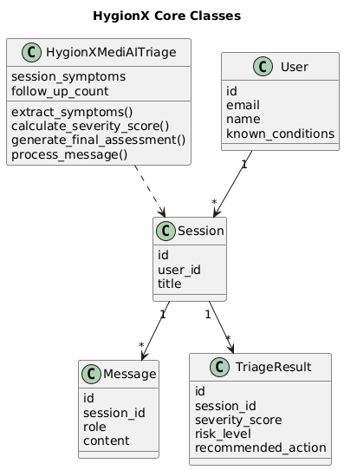
Fig 5.2.1: Class diagram
5.2.2 Sequence Diagram
A Sequence Diagram is a type of UML diagram used to represent the dynamic behavior of a system by showing how different components interact with each other over time. It focuses on the order of messages exchanged between system elements and clearly illustrates the flow of execution from start to end.
This makes the sequence diagram a very useful tool for understanding how a system works internally, especially for processes that involve multiple components communicating with each other. It helps in visualizing real-time interactions, identifying system workflows, and improving system design.
In the context of the HygionX system, the sequence diagram represents how a user interacts with the chatbot and how the request flows through various components such as the User Interface (UI), API (Flask backend), Symptom Extraction Pipeline, Healthcare Intelligence Engine (Triage), and Database (DB).

Dynamic Behaviour in HygionX (Using Diagram)
The sequence diagram shows the step-by-step interaction process:
- The User enters symptoms through the UI.
- The UI sends a request to the backend using a POST API call (/api/chat).
- The API loads the user session and chat history from the database.
- The request is forwarded to the Symptom Extraction Pipeline, which processes the input using NLP techniques.
- The processed data is passed to the Triage Engine, where functions like process_message() are executed.
At this point, the system follows two possible paths:

a. Follow-up Case
- If more information is needed, the system generates a follow-up question
- The message and state are saved in the database
- A follow-up JSON response is sent back to the user

b. Final Assessment Case
- If sufficient data is available, the system generates:
- Severity score
- Urgency level
- Medical advice
- The results are stored in the database
- A final triage JSON response is returned
Finally, the UI displays the response to the user.
This clearly shows how the system dynamically processes user input and generates intelligent healthcare responses.

Key Elements of Sequence Diagram
- Actors: User interacting with the system
- Lifelines: UI, API, Pipeline, Triage, Database
- Messages: API calls, processing requests, responses
- Activation Bars: Show active processing
- Conditions (alt block): Represent decision-making (follow-up vs final result)

Steps to Create a Sequence Diagram
- Identify Actors and Components
Determine who interacts with the system (e.g., User) and system components (UI, API, AI Engine, Database).
- Define the Scenario
Choose a specific process to represent, such as "User entering symptoms and receiving diagnosis."
- List Interactions in Order
Write down the sequence of steps from input to output (API calls, processing, response).
- Draw Lifelines
Represent each component (UI, API, Pipeline, etc.) as vertical lines.
- Add Messages/Arrows
Show communication between components using arrows in time order.
- Include Conditions (alt/loop blocks)
Represent decision points like follow-up questions or final assessment.
- Add Return Responses
Show how results are sent back to the user.
- Refine and Simplify
Ensure the diagram is clear, readable, and logically correct
The sequence diagram of HygionX clearly illustrates the dynamic interaction between system components during a user request. It shows how data flows step-by-step from the user interface to the backend, AI modules, and database. The diagram highlights key decision points such as follow-up questions or final assessment generation. It helps in understanding real-time communication between components like API, pipeline, and triage engine.
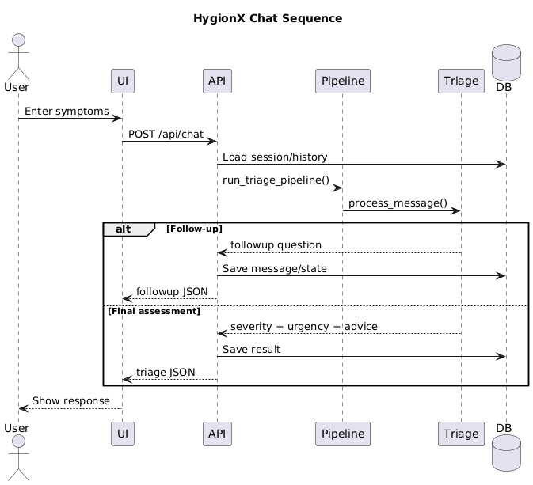
Additionally, it simplifies complex system behavior and improves communication among developers and stakeholders. It is useful for debugging, testing, and optimizing system performance. It also helps identify bottlenecks and ensures smooth workflow execution. Overall, the sequence diagram provides a clear, structured, and efficient view of system operations.

Fig 5.2.2: Sequence diagram
5.2.3 Activity Diagram
Activity Diagram – HygionX Triage Flow The Activity Diagram represents the workflow and step-by-step execution process of the HygionX system when a user interacts with the healthcare chatbot. It is used to model the dynamic behavior and control flow of the system, showing how activities are performed sequentially and how decisions are made at different stages.
The process begins when the user sends a symptom message through the interface. The system first performs input validation to ensure that the provided data is accurate and meaningful. After validation, the system loads the session context, which includes previous chat history and stored user information. This helps maintain continuity and enables personalized responses.
Next, the system executes the triage pipeline, where the input is processed using NLP techniques. During this stage, symptoms are extracted and merged from both the current message and past interactions. This ensures that the system has a complete understanding of the user’s condition before proceeding further.
A key decision point in the workflow is determining whether a follow-up question is needed. If sufficient information is not available, the system generates a follow-up question and returns it to the user. This step may repeat until enough data is collected, forming a loop that improves the accuracy of the final result.
If no follow-up is required, the system proceeds to severity scoring, where it evaluates the seriousness of the condition. Based on this evaluation, the system assigns an urgency level (low, moderate, or high) and builds a complete assessment that includes possible conditions and recommended actions.
Another important decision point is checking whether the situation is an emergency. If classified as an emergency, the system generates an immediate response advising the user to seek urgent medical attention. Otherwise, it provides a standard triage response with appropriate medical guidance.
Finally, all session data and results are stored in the database, including symptoms, analysis, and responses. The process ends after saving the information, ensuring it can be used for future interactions and improved personalization.
Key Features of the Activity Diagram:
- Represents the complete workflow from user input to final output
- Shows important decision points such as follow-up handling and emergency detection
- Demonstrates conditional and iterative flows within the system
- Provides a clear understanding of system logic and execution steps
- Helps identify dependencies and process control mechanisms
Elements Identified Before Drawing :
- Activities (Actions): Steps like validation, symptom extraction, and scoring
- Actors/Participants: User and system modules involved in the process
- Start and End Points: Defines where the workflow begins and ends
- Control Flow: Sequence of operations in the system
- Decision Points: Conditions like follow-up required or emergency detection
- Inputs and Outputs: Data processed and generated at each stage
- Loops/Iterations: Repeated steps such as follow-up questioning
In conclusion, the activity diagram of HygionX provides a clear and structured visualization of the system’s operational flow, from receiving user input to generating and storing results. It effectively represents how different processes are connected and executed in a logical sequence. The diagram highlights key decision-making points, such as follow-up handling and emergency detection, ensuring that the system responds appropriately in different scenarios.
It also helps in understanding how data flows through various stages, including validation, symptom extraction, analysis, and response generation. By clearly showing each step, it simplifies complex system behavior and improves overall clarity. Additionally, it supports better system design, debugging, and performance optimization while enhancing communication among developers and stakeholders. Overall, it contributes to building a reliable, efficient, and scalable healthcare system.

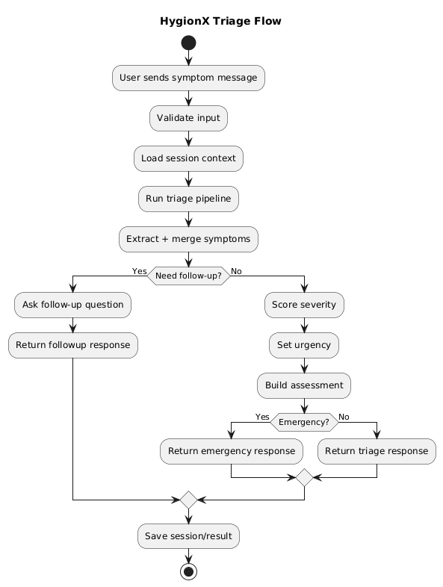
Fig 5.2.3: Activity diagram
5.2.5 Component Diagram
The component diagram of HygionX illustrates the high-level architecture of the system by showing how different software components are organized and interact with each other. It provides a clear view of the system’s modular design, where each component performs a specific function. This diagram helps in understanding how the overall healthcare chatbot system is structured and how different modules collaborate to process user input and generate meaningful medical responses.
The process begins with the User, who interacts with the system through the Frontend UI (HTML/CSS/JS). This interface is responsible for collecting user inputs such as symptoms and displaying the chatbot’s responses. It ensures a smooth and user-friendly experience by enabling real-time communication. The frontend sends user requests to the backend through API calls, acting as a bridge between the user and the system’s internal processing modules.
The Flask Backend (app.py) acts as the central controller of the system. It receives requests from the frontend, processes them, and coordinates communication between various components. The backend directs the input to the Triage Pipeline (triage_pipeline.py), which performs initial processing and prepares the data for analysis. This pipeline then forwards the processed information to the Triage Engine (HygionXMediAITriage), where core decision-making operations such as symptom analysis, severity scoring, and recommendation generation are performed
The Triage Engine depends on the ML Model Loader (model_loader.py) to load and utilize trained machine learning models for accurate predictions. At the same time, the backend interacts with the MySQL database (via SQLAlchemy models.py) to store and retrieve user data, session details, chat history, and analysis results. This ensures data persistence and enables personalized healthcare recommendations based on past interactions. The database plays a crucial role in maintaining system reliability and continuity.
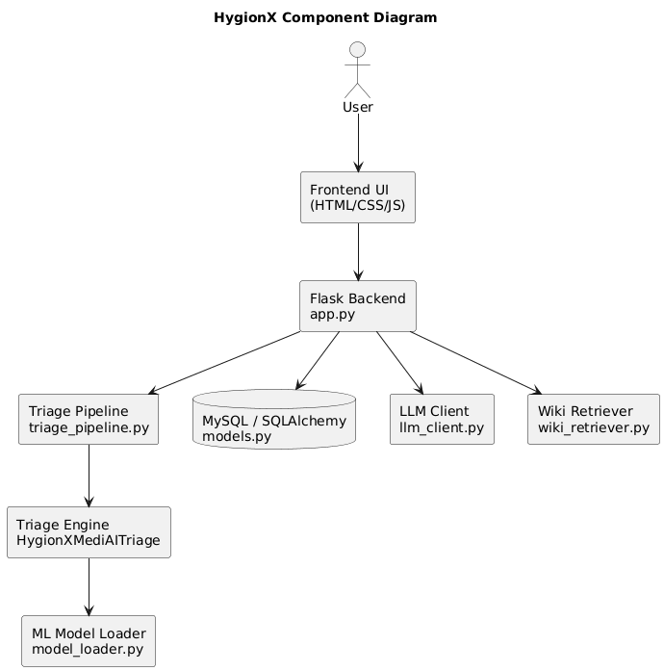
In addition to core components, the system integrates external modules such as the LLM Client (llm_client.py) and the Wiki Retriever (wiki_retriever.py). The LLM Client enhances response generation by improving language understanding and producing more natural, context-aware replies. The Wiki Retriever fetches relevant medical information from external sources to provide additional knowledge to users. Overall, the component diagram highlights a well-structured, scalable, and modular architecture that ensures efficient communication, easy maintenance, and future extensibility of the HygionX system.
Fig 5.2.4: Component diagram
5.2.6 Deployment Diagram
The Deployment Diagram represents the physical architecture of the HygionX system, showing how software components are deployed on hardware nodes and how they communicate with each other in a real-world environment. It provides a clear understanding of where each component is located and how data flows across different parts of the system.
In the HygionX system, the deployment begins with the Client Device, which can be a mobile phone, laptop, or web browser. The user interacts with the system through the Frontend UI (HTML, CSS, JavaScript). This interface allows users to enter symptoms and view chatbot responses. The frontend communicates with the backend server using HTTP/HTTPS protocols, ensuring secure and real-time data exchange.
The Web/Application Server, implemented using Flask (Python), acts as the central controller of the system. It handles incoming requests from the frontend through API endpoints such as /api/chat. The backend manages session handling, routing, and communication between internal components. It ensures that user requests are properly processed and forwarded to the appropriate modules for further analysis.
The system also includes an AI Processing Server, which is responsible for performing intelligent analysis of user input. This server contains components such as the Triage Pipeline, Triage Engine, and ML Model Loader. These components work together to process user symptoms using NLP techniques, extract relevant information, calculate severity levels, and generate healthcare recommendations. This separation of AI processing improves performance and scalability.
The Database Server, using MySQL with SQLAlchemy, stores all essential data including user profiles, sessions, chat messages, and triage results. It ensures data persistence and enables the system to provide personalized responses based on previous interactions. The backend communicates with the database server through secure internal connections to store and retrieve information efficiently.
Additionally, the system integrates External Services such as Firebase Authentication, LLM APIs, and Wiki Retrieval APIs. These services provide authentication, enhanced response generation, and additional medical knowledge. They are accessed via the internet and improve the overall functionality and intelligence of the system.
The communication between all these components is carried out through secure network channels, including HTTP/HTTPS for client-server communication and internal network connections for backend interactions. This ensures reliable and secure data transfer across the system.
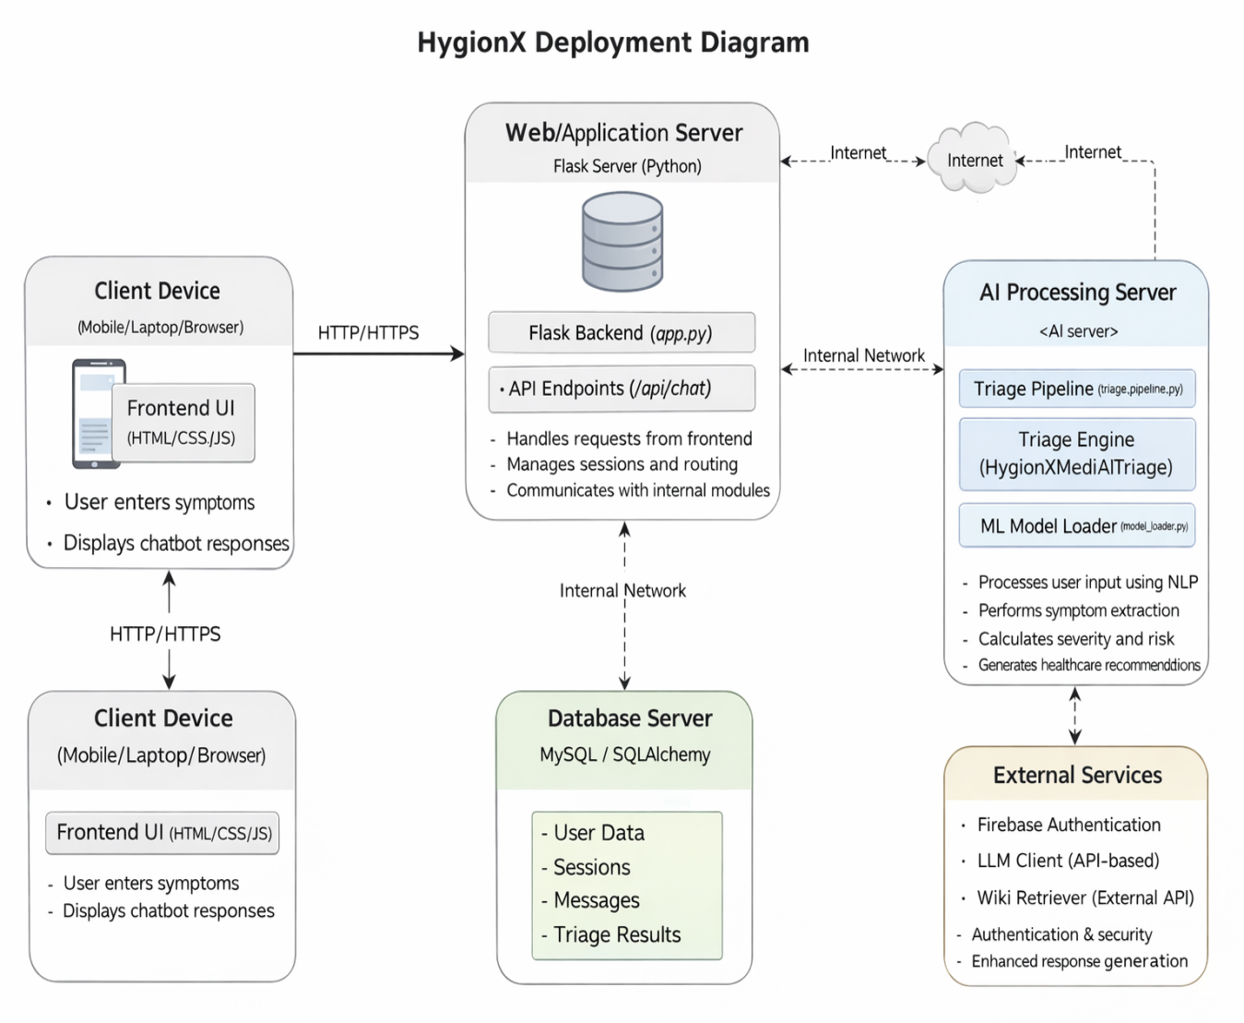

Fig 5.2.5: Deployment diagram

Chapter 6

SYSTEM IMPLEMENTATION
6.1 IMPLEMENTATION PROCESS
The system implementation process of HygionX involves the systematic development and integration of various components to build a fully functional AI-powered healthcare chatbot. It transforms the conceptual system design into a practical, real-world application by combining multiple layers such as the frontend, backend, database, and AI modules. This process ensures that each component is developed independently and then integrated seamlessly to achieve smooth communication and efficient performance.
The implementation follows a structured approach, starting from environment setup and progressing through interface design, backend logic development, database configuration, and AI model integration. Each module is carefully designed to handle specific tasks, such as user interaction, data processing, storage, and intelligent decision-making. Proper coordination between these modules ensures accurate symptom analysis, reliable response generation, and secure data handling.
Additionally, the system incorporates modern technologies such as Natural Language Processing, machine learning models, and API-based services to enhance its capabilities. The implementation process also emphasizes scalability, security, and maintainability, allowing the system to handle increasing user demands and future enhancements. Overall, this structured implementation approach ensures that HygionX operates efficiently, delivers personalized healthcare guidance, and provides a reliable and user-friendly experience.
- Environment Setup
The implementation begins with setting up the development environment. This includes installing tools such as Python, Flask, MySQL, and libraries like HuggingFace Transformers, SciSpacy, and PyTorch. Development platforms like VS Code and Jupyter Notebook are used for coding and testing. Proper setup ensures smooth development and compatibility between system components.

- Frontend Development
The frontend is developed using HTML, CSS, and JavaScript to create a user-friendly interface. It allows users to input symptoms and view chatbot responses in real time. The interface is designed to be responsive and intuitive, ensuring ease of use. It also handles communication with the backend through API calls.
- Backend Development
The backend is implemented using the Flask framework. It provides RESTful APIs that process user requests and return responses. The backend manages session handling, routing, and communication between different modules. It acts as the central controller of the system, ensuring smooth data flow.
- Database Integration
The system uses MySQL with SQLAlchemy for data storage. It stores user profiles, chat history, sessions, and triage results. The database ensures data persistence and supports personalized responses based on previous interactions. Efficient database design improves performance and reliability.
- AI and NLP Integration
The core functionality is implemented using AI and NLP techniques. HuggingFace transformers are used for text processing, and SciSpacy is used for symptom extraction. The triage engine analyzes the data, calculates severity levels, and generates recommendations. This module is responsible for intelligent decision-making.
- External Services Integration
The system integrates external services such as Firebase Authentication for secure login and APIs for knowledge retrieval and response enhancement. These services improve system functionality by adding security, scalability, and additional medical insights.
- Testing and Validation
After development, the system undergoes thorough testing. Different test cases are used to verify input handling, response accuracy, and system performance. Errors and bugs are identified and fixed to ensure reliability and correctness of the system.

- Deployment
Finally, the system is deployed on servers or cloud platforms. The frontend is made accessible to users, while the backend, database, and AI modules are hosted securely. Proper deployment ensures that the system runs efficiently in a real-world environment.

The system implementation process of HygionX ensures that all components are developed, integrated, and deployed in a coordinated and efficient manner. It brings together the frontend, backend, database, and AI modules into a unified system that functions smoothly in real-world scenarios. This integration enables seamless communication between components, ensuring that user inputs are processed accurately and responses are generated effectively.
By incorporating advanced technologies such as Natural Language Processing and machine learning, the system is able to provide accurate, personalized, and explainable healthcare support. The implementation also focuses on maintaining data security and privacy through proper authentication and secure storage mechanisms.
Furthermore, this structured approach improves system reliability by minimizing errors and ensuring consistent performance under different conditions. It also supports scalability, allowing the system to handle increasing user loads and additional features in the future. Overall, the implementation process lays a strong foundation for continuous improvement, adaptability, and long-term sustainability of the HygionX system.

6.2 MODULE IMPLEMENTATION
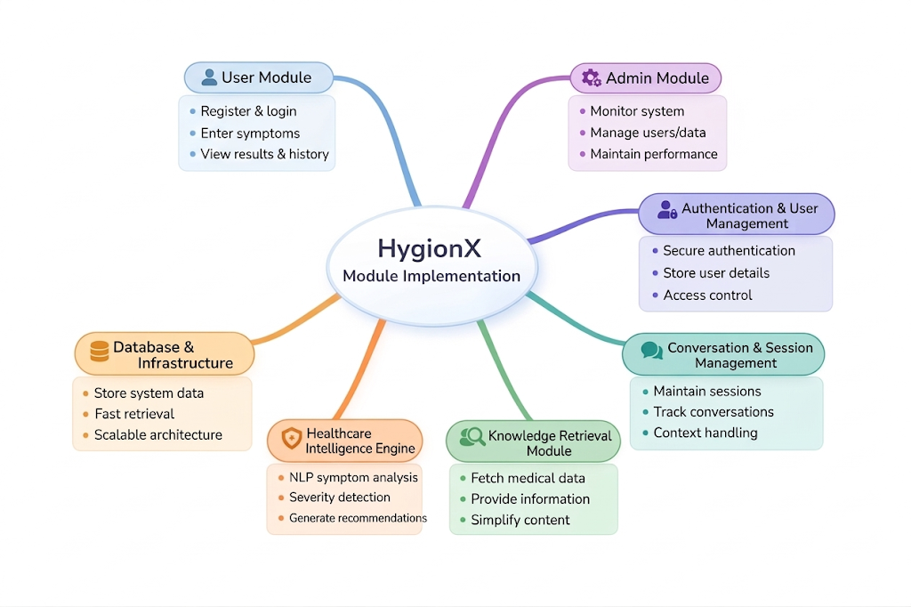
The HygionX system is implemented through several major modules, each responsible for handling a specific part of the application. These modules are designed in a structured and modular way to ensure smooth development, easy maintenance, and efficient system performance. Each module performs a dedicated function, and together they form a complete AI-powered healthcare chatbot system

User Module:
The User Module enables users to interact with the HygionX system through a web-based interface. It allows users to register and log in securely to access the platform. Once authenticated, users can enter their symptoms in natural language and receive AI-generated healthcare guidance.
This module also allows users to view their previous results and interaction history, ensuring continuity and personalization. It plays a crucial role in delivering a smooth and user-friendly experience.
Admin Module:
The Admin Module is responsible for managing and monitoring the overall system operations. It allows administrators to oversee user activity, manage stored data, and ensure that the system performs efficiently.
This module helps maintain system stability by monitoring performance, handling system configurations, and ensuring that all components function without disruption. It is essential for maintaining reliability and proper system management.

Authentication & User Management Module:
This module handles secure authentication and user account management. It enables users to register and log in using a secure authentication system, ensuring that only authorized users can access the platform.
User details such as personal information and medical data are stored securely, and proper access control mechanisms are implemented. This module enhances both security and personalization within the system.

Conversation & Session Management Module:
The Conversation & Session Management Module manages the interaction flow between the user and the chatbot. It maintains session continuity by storing chat history and tracking ongoing conversations.
This module ensures that context is preserved across multiple interactions, allowing the system to provide meaningful follow-up questions and accurate responses. It plays a key role in improving the consistency and intelligence of the chatbot.

Knowledge Retrieval Module:
The Knowledge Retrieval Module is responsible for fetching medical information from external sources such as medical databases or APIs. It provides users with relevant and accurate information related to diseases and conditions.
The module presents this information in a simplified and easy-to-understand format, helping users gain better insights into their health. It enhances the informational capability of the system beyond basic predictions.
Healthcare Intelligence Engine:
The Healthcare Intelligence Engine is the core component of the HygionX system. It processes user input using Natural Language Processing (NLP) techniques to extract symptoms and relevant medical information.
This module analyzes symptom severity, determines risk levels, and generates appropriate recommendations. It also provides explainable outputs, including reasoning and confidence scores, which improve user trust and system reliability.

Database & Infrastructure Module:
The Database & Infrastructure Module is responsible for storing and managing all system data. It maintains user profiles, chat history, detected symptoms, and triage results in a structured database.
This module ensures efficient data retrieval, data consistency, and long-term storage. The infrastructure is designed to be scalable and reliable, supporting smooth system performance and future expansion.

The module implementation of HygionX provides a well-structured approach to building a complete AI-powered healthcare chatbot system. By dividing the system into distinct modules such as user interaction, administration, authentication, session management, knowledge retrieval, intelligence processing, and data storage, each component can be developed and managed efficiently.

Furthermore, the integration of all modules ensures seamless communication between system components, enabling accurate data processing and real-time response generation. This modular architecture improves scalability, flexibility, and maintainability, making the system suitable for real-world deployment and future enhancements.

Chapter 7
SYSTEM STUDY & TESTING

7.1 FEASIBILITY STUDY
The feasibility of the HygionX system is analyzed to ensure that the proposed AI-based medical triage application is practical, efficient, and beneficial for users. This study evaluates whether the system can be developed and deployed without excessive resource demands while delivering meaningful healthcare guidance.

The feasibility analysis considers the following key aspects:
- Technical Feasibility
- Social Feasibility
- Economical Feasibility

- Technical Feasibility
This study evaluates whether the required technology and resources are available to develop and run the system efficiently.
The HygionX system is technically feasible as it is built using widely adopted and scalable technologies such as Flask, Firebase Authentication, SQLAlchemy, and machine learning components.
- The system supports both ML-assisted mode and fallback rule-based mode, ensuring reliability even when advanced models are unavailable.
- It does not require high-end hardware and can run on standard web servers.
- The modular architecture enables smooth integration between frontend, backend, and AI components.
- The system is designed to be scalable and maintainable for future enhancements.
Thus, the system has moderate technical requirements and can be implemented effectively.

- Social Feasibility
This aspect evaluates the level of acceptance of the system among users.
HygionX is designed to be user-friendly and accessible, ensuring high acceptance among users. The system can be easily accessed through standard web browsers without requiring installation or technical expertise, making it convenient for a wide range of users.
- The chat-based interface allows users to describe symptoms naturally.
- The system provides clear explanations, risk levels, and recommendations, improving user trust.
- Safety disclaimers are included to ensure users understand that it is not a replacement for professional medical advice.
- Minimal training is required due to the intuitive interface.
Hence, the system is socially acceptable and easy to adopt.

- Economic Feasibility
This study evaluates the cost-effectiveness of the system.
The HygionX system is economically feasible as it utilizes mostly open-source and freely available technologies. Additionally, the system requires minimal maintenance and operational costs, making it financially sustainable in the long run.
- Technologies such as Flask and Python libraries are open-source.
- Firebase provides scalable authentication with a free tier.
- Deployment and maintenance costs are relatively low.
- The system can scale gradually without significant additional cost.

Additionally, the system provides indirect economic benefits:
- Reduces unnecessary hospital visits for minor conditions
- Saves time for both users and healthcare providers
- Provides quick preliminary guidance, improving efficiency
Thus, the system is cost-effective and financially viable.

7.2 SOFTWARE TESTING
The purpose of testing is to identify errors and ensure that the HygionX system functions correctly, efficiently, and safely. Testing verifies that the system meets user requirements and provides reliable medical guidance. In addition to validating correctness, testing in HygionX focuses on ensuring continuity of conversation, accurate symptom interpretation, proper urgency classification, and smooth interaction between system components.
There are various types of tests. Each type of test address a specific testing requirement.

Types of Testing:
- Unit Testing
- IntegrationTesting
- System Testing
- Performance Testing
- Acceptance Testing

- Unit Testing:
Unit testing involves verifying individual components of the system in isolation to ensure that each module performs its intended function correctly. This type of testing is carried out during the development phase and focuses on validating internal logic and data processing.
In HygionX, unit testing is applied to critical components such as:
- Symptom extraction modules, including both machine learning-based and rule-based fallback approaches
- Severity scoring algorithms that compute risk levels based on detected symptoms
- Emergency detection logic that identifies high-risk conditions
- API endpoints and backend utility functions
Each unit is tested with multiple input scenarios, including valid, invalid, and edge-case inputs, to ensure robustness. Unit testing helps detect errors early, reduces debugging effort in later stages, and ensures a strong foundation for integration.

Test Case ID | Input | Function | Expected Output | Result
UT-01 | "I am suffering from fever and headache” | Symptom Extraction | ["fever", "headache"] | Passed
UT-02 | Symptoms list | Severity Scoring | Score between  1–10 | Passed
UT-03 | Chest pain | Urgency Detection | “Emergency” | Passed
UT-04 | API Health request | EndpointValidation | Status OK | Passed
Table 7.2.1 : Unit Testing
- Integration Testing:
Integration testing evaluates the interaction between different modules of the system to ensure that they work together seamlessly. While individual components may function correctly on their own, integration testing verifies that combined modules exchange data properly and produce correct results.
In HygionX, integration testing focuses on:
- Communication between the frontend user interface and backend APIs
- Interaction between the chat API and the triage engine
- Authentication and session management using Firebase
This testing ensures that user inputs are correctly transmitted, processed, and stored, and the responses generated by system are accurate and consistent across modules.
Test Case ID | Module Interaction | Input | Expected Output | Result
IT-01 | Chat UI => API | User message | Valid structured response returned | Passed
IT-02 | API =>Triage Engine | Symptoms text | Follow-up or final assessment generated | Passed
IT-03 | Triage Engine => Database | Final result | Stored successfully | Passed
IT-04 | Authentication => Backend | Valid Token | User Authenticated Successfully | Passed
Table 7.2.2 : Integration Testing
- System Testing:
System testing evaluates the complete HygionX application as a fully integrated system. It ensures that all components work together correctly and that the system behaves as expected in real-world scenarios.
This testing phase includes:
- End-to-end validation of the chat-based triage workflow
- Verification of multi-turn conversations and context retention
- Testing of emergency detection and escalation mechanisms
- Evaluation of system responses for both typical and edge-case inputs
- Verification of user interface behavior and clarity of displayed results
System testing simulates real user interactions and helps identify issues related to overall system functionality, usability, and stability.
Test Case ID | Scenario Description | Input Provided | Expected System Behaviour | Result
ST-01 | User enters multiple symptoms in a single message | "I have fever, headache and nausea" | System extracts all symptoms and generates relevant follow-up questions | Passed
ST-02 | User provides emergency-related symptoms | "I have severe chest pain and difficulty breathing" | System immediately classifies as emergency and displays urgent medical advice | Passed
ST-03 | User enters mild/common symptoms | "I have a mild cough and cold" | System classifies as low/moderate risk and provides guidance | Passed
ST-04 | User provides incomplete or vague input | "I feel unwell" | System asks clarification questions to gather more details | Passed
ST-05 | User enters invalid or unrelated input | Random text or empty input | System handles without crashing and prompts user again | Passed
ST-06 | Multi-turn conversation scenario | Sequential symptom inputs across messages | System retains previous context and refines assessment | Passed
ST-07 | User reaches maximum follow-up limit | Multiple incomplete responses across turns | System stops follow-ups and generates final assessment | Passed
Table 7.2.3 : System Testing
- Performance Testing:
Performance testing evaluates the responsiveness, scalability, and stability of the HygionX system under varying workloads and conditions. Since the system is developed in a local environment and not deployed for real-world usage, performance testing is conducted by simulating concurrent user interactions.
In HygionX, performance testing includes:
- Measuring response time of the chat API for different types of inputs
- Simulating multiple concurrent requests using browser sessions and repeated API calls
- Evaluating system behavior under continuous and rapid request conditions
- Identifying potential bottlenecks in processing or data handling
Performance testing was conducted in a controlled local environment by simulating concurrent usage through multiple browser instances and repeated requests to the backend. This approach helps ensure that the system remains responsive and stable even under increased load conditions.

Test Case ID | Scenario | Input Provided | Expected Output | Result
PT-01 | Simulated concurrent requests | Multiple parallel requests to chat API | Response time < 2 seconds | Passed
PT-02 | Continuous request handling | Repeated API calls over time | No system crash or performance degradation | Passed
PT-03 | Large input processing | Long symptom descriptions | System processes input without delay or failure | Passed
PT-04 | LLM response handling | Complex symptom input requiring detailed analysis | System generates response within acceptable time without timeout | Passed
Table 7.2.4 : Performance Testing

- Acceptance Testing:
Acceptance testing is the final phase of testing, where the system is evaluated from the user’s perspective to determine whether it meets the specified requirements and expectations. This testing ensures that the system is ready for deployment.
In HygionX, acceptance testing focuses on:
- Usability and ease of interaction with the chat interface
- Clarity and usefulness of the medical guidance provided
- Accuracy of symptom-based triage results
- Overall user satisfaction and experience
This phase may involve feedback from test users, helping to identify any remaining issues or improvements before final deployment.

Test Case ID | Criteria | Expected Behaviour | Result
AT-01 | Basic symptom input | Clear triage result displayed | Passed
AT-02 | Follow-up interaction | Logical questions asked | Passed
AT-03 | Emergency case | Immediate warning displayed | Passed
AT-04 | UI clarity | Results displayed clearly | Passed
AT-05 | User experience | Smooth and intuitive interaction | Passed
AT-06 | Display of confidence score | System displays confidence score clearly along with assessment | Passed
Table 7.2.5 : Acceptance Testing

Chapter 8
SOURCE CODE

Chapter 9
SCREEN LAYOUTS

9.1 INTERFACE LAYOUT
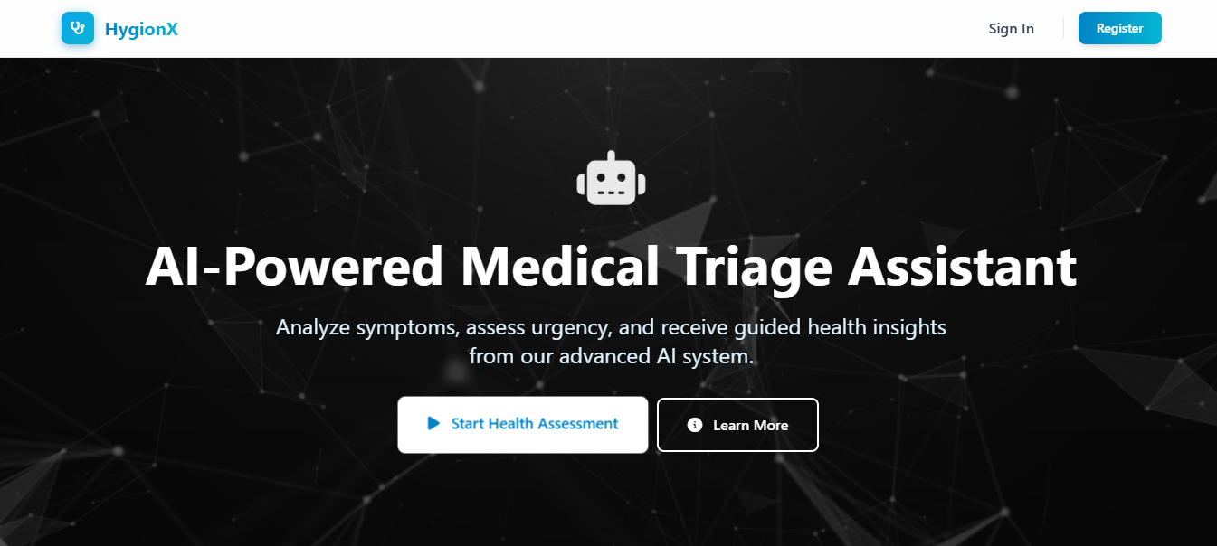
Fig 9.1.1 : Landing Page

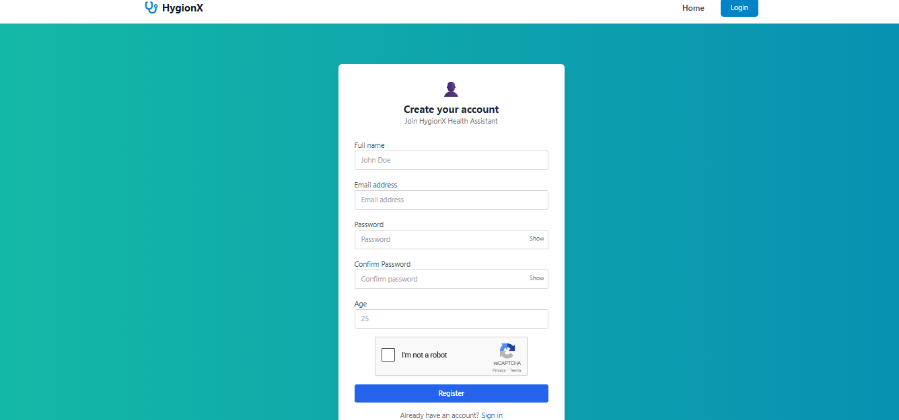
Fig 9.1.2 : Authentication Interface

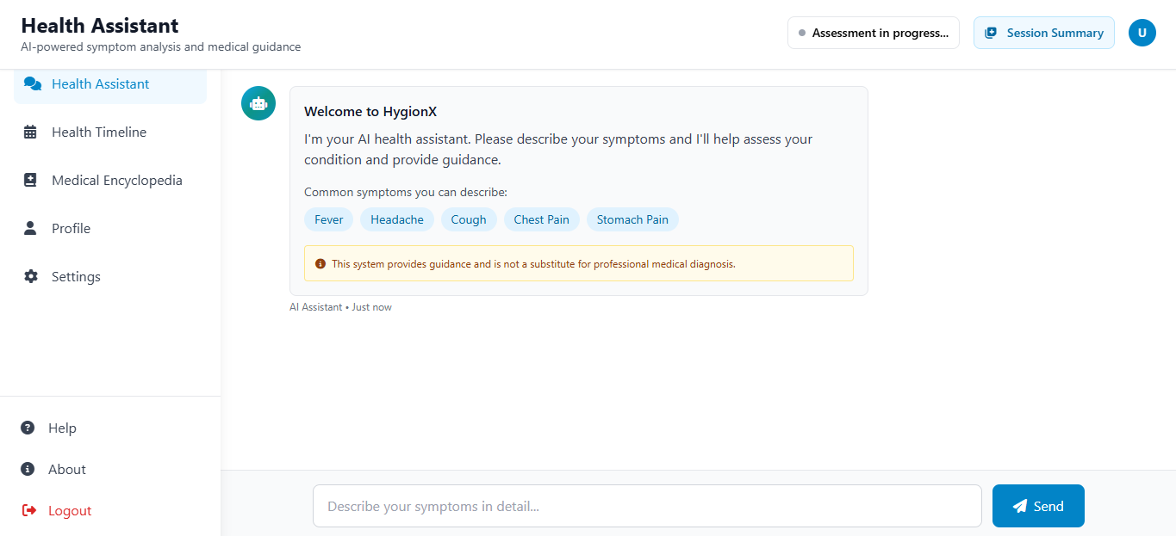
Fig 9.1.3 : Health Assistant Interface

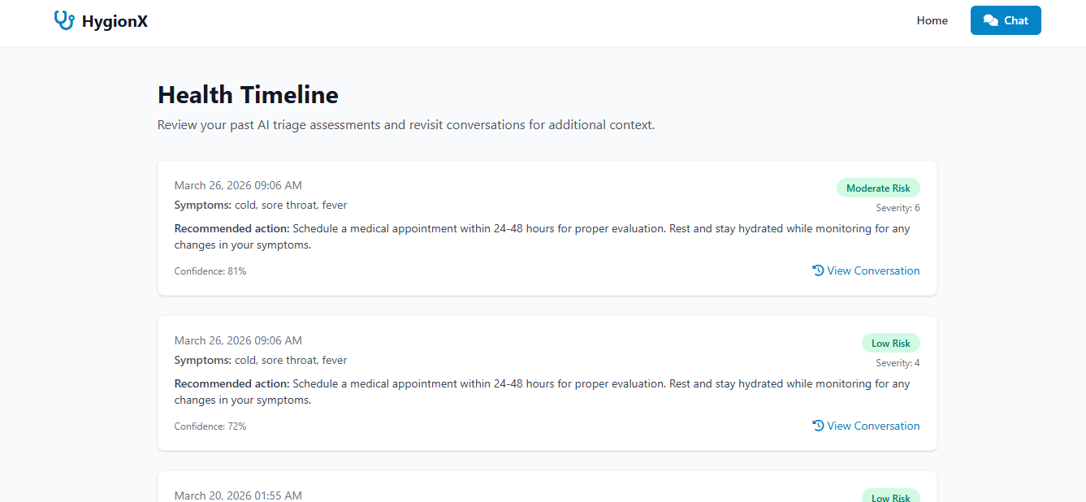
Fig 9.1.4 : Health Timeline Interface

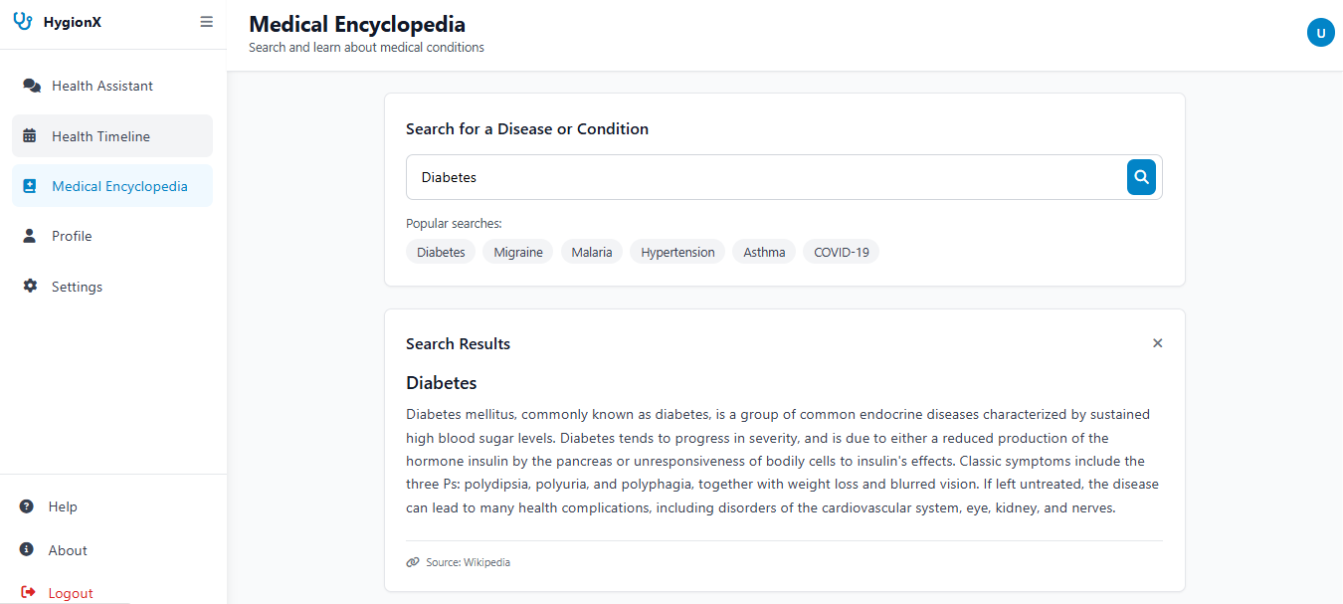
Fig 9.1.5 : Medical Encyclopedia Interface

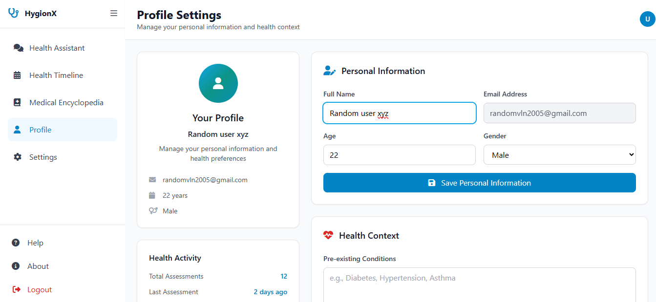
Fig 9.1.6 : Profile Interface
9.2 RESULTS

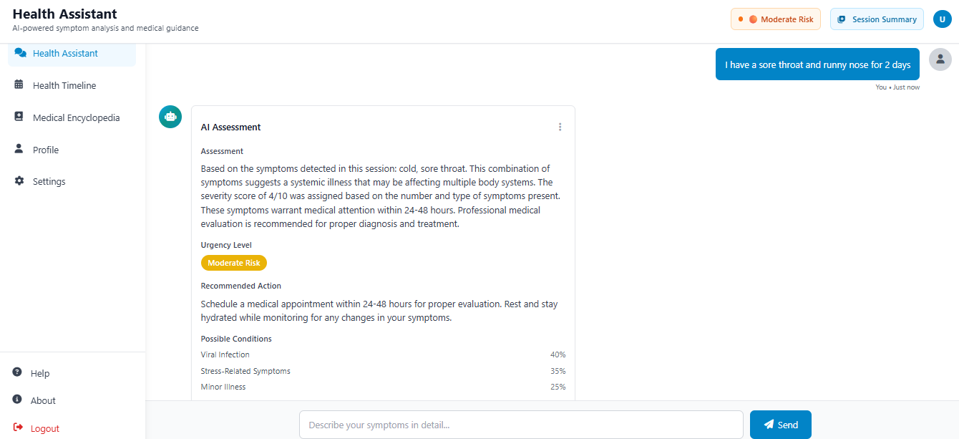
Fig 9.2.1 : Chat Output
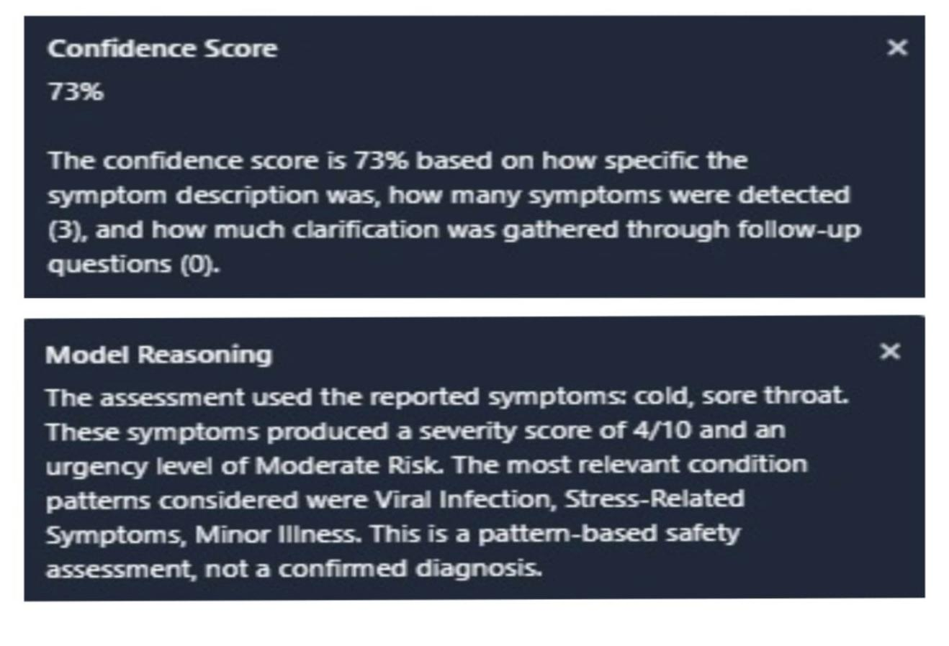
Fig 9.2.2 : Confidence scores and reasoning
Chapter 10
FUTURE ENHANCEMENTS

The HygionX system provides a strong foundation for an AI-based medical triage assistant; however, several enhancements can be incorporated to further improve its capabilities and real-world applicability.
One of the major future enhancements is the integration of advanced domain-specific language models such as BioBERT, ClinicalBERT, or other medical LLMs. These models can improve the system’s ability to understand complex medical queries, interpret user inputs more accurately, and generate more context-aware responses.
Another important enhancement is the incorporation of real-time medical knowledge bases and APIs. By connecting the system to trusted medical sources, the chatbot can provide updated medical information and more accurate recommendations aligned with current healthcare standards.
The system can also be enhanced by supporting multilingual interaction, making it accessible to a wider population and improving usability for users from different linguistic backgrounds.
Personalization can be further improved by incorporating deeper user health profiling, including past medical history, allergies, and previous interactions, enabling more precise and individualized triage results.
Integration with wearable devices and health monitoring systems can further enhance the system by enabling real-time data analysis and early detection of potential health issues.
Additionally, security and privacy can be strengthened by implementing advanced encryption and secure authentication mechanisms to protect sensitive health data.
The system can also be extended to support voice-based interaction, improving accessibility for elderly users and individuals with disabilities.
Finally, integrating telemedicine features such as doctor consultation and appointment booking can transform HygionX into a more comprehensive digital healthcare solution.

Chapter 11
CONCLUSION

The HygionX system successfully demonstrates the application of artificial intelligence in delivering preliminary medical guidance through an interactive, user-friendly chatbot interface. The system is designed to interpret user-reported symptoms, conduct a structured triage process, and generate meaningful health assessments along with appropriate recommendations, thereby improving accessibility to basic healthcare support.
By integrating natural language processing, rule-based logic, and optional machine learning components, HygionX effectively understands user inputs, extracts relevant symptoms, and classifies the level of risk into categories such as low, moderate, high, or emergency. The system maintains conversational context across multiple interactions, enabling more accurate and consistent analysis through follow-up questioning and symptom aggregation.
A key strength of the system lies in its emphasis on explainability and transparency. Along with the triage results, HygionX provides a clear explanation of the reasoning behind its predictions. Additionally, the inclusion of a confidence score for each assessment plays a crucial role in conveying the reliability of the output, allowing users to make informed decisions, especially when professional consultation is recommended.
Furthermore, the system is designed with flexibility and robustness, supporting both ML-assisted and fallback modes to ensure uninterrupted functionality even in resource-constrained environments. Security features such as authentication and controlled data handling further ensure the safe management of sensitive user information.
In conclusion, HygionX serves as a reliable AI-based medical triage assistant that bridges the gap between basic symptom checking and intelligent healthcare support. While it does not replace professional medical diagnosis, it provides valuable preliminary insights, promotes informed decision-making, and contributes to enhancing digital healthcare accessibility and user awareness.

Chapter 12
BIBILOGRAPHY

- Jegadeesan, R., Srinivas, D., Umapathi, N., Karthick, G., & Venkateswaran, N.
(2023). Personal healthcare chatbot for medical suggestions using artificial intelligence and machine learning. European Chemical Bulletin, 12(S3).
- Bickmore, T. W., & Giorgino, T. (2006). Health dialog systems for patients and consumers. Journal of Biomedical Informatics, 39(5), 556–571.
- Laranjo, L., Dunn, A. G., Tong, H. L., et al. (2018). Conversational agents in healthcare: A systematic review. Journal of the American Medical Informatics Association, 25(9), 1248–1258.
- Rajkomar, A., Dean, J., & Kohane, I. (2019). Machine learning in medicine. New England Journal of Medicine, 380(14), 1347–1358.
- Topol, E. (2019). High-performance medicine: The convergence of human and artificial intelligence. Nature Medicine, 25(1), 44–56.
- Devlin, J., Chang, M. W., Lee, K., & Toutanova, K. (2019). BERT: Pre-training of deep bidirectional transformers for language understanding. NAACL-HLT.
- Vaswani, A., Shazeer, N., Parmar, N., et al. (2017). Attention is all you need. Advances in Neural Information Processing Systems (NeurIPS).
- Miner, A. S., Milstein, A., & Hancock, J. T. (2017). Talking to machines about personal mental health problems. JAMA, 318(13), 1217–1218.
- WHO (World Health Organization). (2020). Digital health interventions for health system strengthening.
- FDA (Food and Drug Administration). (2021). Artificial Intelligence and Machine Learning in Software as a Medical Device.
- Chen, M., & Decary, M. (2020). Artificial intelligence in healthcare: An essential guide for health leaders. Healthcare Management Forum, 33(1), 10–18.

- Bibault, J. E., Chaix, B., Guillemassé, A., et al. (2019). A chatbot versus physicians to provide information for patients with breast cancer. Journal of Medical Internet Research, 21(11).
- Denecke, K., et al. (2019). Artificial intelligence for patient support: A review of AI chatbots in healthcare. Health Informatics Journal.
- Shortliffe, E. H., & Sepúlveda, M. J. (2018). Clinical decision support in the era of artificial intelligence. JAMA, 320(21), 2199–2200.
- Jiang, F., Jiang, Y., Zhi, H., et al. (2017). Artificial intelligence in healthcare: Past, present and future. Stroke and Vascular Neurology, 2(4), 230–243.
- Beam, A. L., & Kohane, I. S. (2018). Big data and machine learning in healthcare. JAMA, 319(13), 1317–1318.
- Obermeyer, Z., & Emanuel, E. J. (2016). Predicting the future — Big data, machine learning, and clinical medicine. New England Journal of Medicine, 375(13), 1216– 1219.
- Razzaki, S., Baker, A., Perov, Y., et al. (2018). A comparative study of artificial intelligence and human doctors for triage and diagnosis. npj Digital Medicine, 1(1), 1–8.
- Amisha, Malik, P., Pathania, M., & Rathaur, V. K. (2019). Overview of artificial intelligence in medicine. Journal of Family Medicine and Primary Care, 8(7), 2328– 2331.
- Davenport, T., & Kalakota, R. (2019). The potential for artificial intelligence in healthcare. Future Healthcare Journal, 6(2), 94–98.

